System REQUIREMENTS SPECIFICATION
for
eCMS - Dymanic reports

Release No 1.1 – Jul2021

document identification no 3 char SYS ID/ DOC CODE /NN/ V M.n)  for details refer to document mgmt stds | document title | status  (draft/ RELEASED) | date of release | pages
eCMS /SRS/01/V1.1 | System Requirement Specifications For eCMS Dynamic reports | Draft | 07.2021

 | role in the project | Name | signature | date  (dd-mm-yy)
Authors | Technical Team
Reviewers | Project Lead | Sujit Patra
Approver | Project Manager | Raghavan Jaganathan

Endorsement by System Owner (internal)
 | Name | designation | signature | date  (dd-mm-yy)
Endorsed by System Owner | Chiew Lan Tan | Senior Director

release history
Release Number | associated change request number | Date (mm,yyyy) | Brief Summary of changes | Author
1.1 | First Release | 07.2021 | - eCMS Dynamic Report | Santosh Subba

Contents
1. Introduction 4
1.1 Definitions and Abbreviations 4
1.2 References 5
2. Functional Requirements 6
2.1 Dynamic Reports Overview 6
2.2 Pre-Requisites and Assumptions 6
3. Dynamic Report Architecture 7
3.1 Process flow for Dynamic report 8
3.2 Use case for Dynamic report 9
4. Dynamic Reports Fact transaction mapping table 9
4.1 ECMS_ Fact_Declaration_Line__item 10
4.2 ecms_Fact_Revenue 12
4.3 ECMS Fact Exemption 12
4.4 ECMS_Fact_Clearances 14
4.5 ECMS_Fact_Offence 15
4.6 ECMS_Fact_Refund 16
4.7 ECMS_Fact_Manifest 16
4.8 ECMS_Fact_Passenger_manifest 18
4.9 ECMS_FACT_BHUTAN TRADE STATISTIC 19
4.10 BTC & TARIFF SCHEDULE 20
4.11 Dash board 21

Introduction
This document defines & illustrates the Dynamic Reports requirements, process flows as well as the detailed requirements of eCMS Dynamic Report module to be implemented for Department of Revenue and Customs, Bhutan.

Definitions and Abbreviations
The table below lists the different acronyms and abbreviations as well as the definitions used throughout this SRS.

S/N | Abbreviations | Description
 | ACT | Authorized Compliant Trader
 | BNB | Bhutan National Bank
 | BOB | Bank of Bhutan
 | BITS | Bhutan Integrated Tax System
 | BSTEC | Bhutan Sales Tax Exemption Certificate
 | BTC | Bhutan Tariff Classification
 | CID | Citizens Identification Number
 | CRRB | Customs Rules and Regulations of Bhutan
 | DITT | Department of Information Technology & Telecom
 | DRC | Department of Revenue & Customs
 | eCMS | Electronic Customs Management System
 | EMS | Express Mail Service
 | FRS | Functional Requirements Specification
 | RTO | Regional Trade Office
 | SARC | South Asian Association for Regional Cooperation
 | RGOB | Royal Government of Bhutan
 | MOHCA | Ministry of Home and Cultural Affairs
 | RRCO | Regional Revenue and Customs Office
 | SITA | International Aeronautical Telecommunications Society
 | SCTS | Single Customs Trade System
 | SAD | Single Administration Document
 | Nu | Ngultrum
 | LTO | Liaison and Transit Office
 | LOG | Letter of Guarantee
 | LCS | Land Customs Station
 | IDEC | Import Duty Exemption Certificate
 | GST | Goods and Services Tax
 | CFA | Clearing and Forwarding Agent
 | CDS | Customs Declaration System
 | CAB | Customs Act of Bhutan
 | TPN | Taxpayer Number

References
The creation of the BECMS SRS was referenced using the following documents:
- FUNCATIONAL REQUIREMENT SPECIFICATION.docx
- TECHNICAL REQUIREMENT SPECIFICATION.docx
- Bhutan eCMS Technical Proposal TECH-3.pdf
- Bhutan eCMS Technical Proposal TECH-4.pdf
- Bhutan eCMS Technical Proposal TECH-5A.pdf
- Bhutan eCMS Technical Proposal TECH-5B.pdf
- Bhutan eCMS Technical Proposal TECH-6A.pdf
- Bhutan eCMS Technical Proposal TECH-6B.pdf

Functional Requirements

Dynamic Reports Overview
Dynamic Report is a report that enables users to perform various type of data discovery and analysis (such as drilling down, filtering, or sorting) with ease. The purpose of dynamic reports is to allow users to independently conduct deeper mining and custom reports on demand based on the extracted XLS values. In addition, the end-user can also export into PDF or Excel without asking help from the developers from the available data mart.

Dynamic Reports generated from the data mart, which is consist of data mart of a particular business process Examples, like Details of Import and export Transactions.

Pre-Requisites and Assumptions
- User should have valid credential and able to access the Dynamic report
- User can access the report base on their roles assigned by super admin.
- Dynamic Report can be design using Agreed Report Designer example Pentaho or Power BI.
- Dynamic Reports can be managed using specified date range.
- We always recommend extracting with shorter duration for the better performance
- User should have option extracting the report either PDF or Excel format depend on user’s requirement.
- All financial data will be held in a minimum of 10.2 (10 digit and 2 decimal digits) format or greater in alignment with international standard.

Dynamic Report Architecture
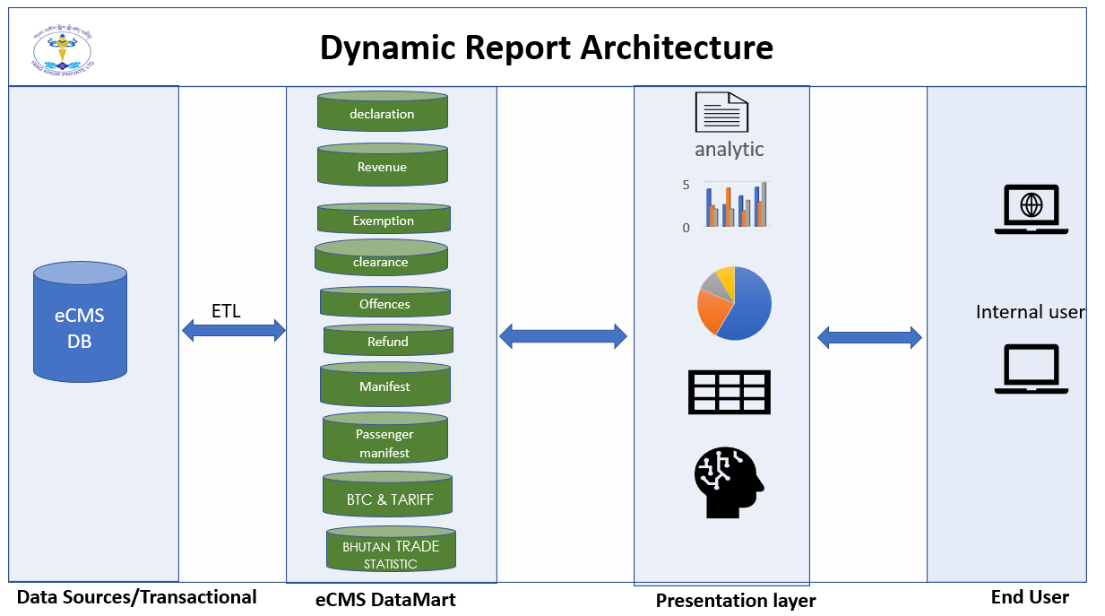

- Data sources: eCMS transactional details are the primary sources of the Data marts to eCMS fact tables.

- eCMS Data marts: eCMS Data Marts contain repositories of summarized data collected for the analysis on a specific unit for the report. We can use ETL (Extract, Transfer and Load) process to load the data from data sources (transactional database) to the specifies Fact table. So, Fact table can store the cleans analysis data for the analytic.

- Presentation Stage: In Analytic stage we can use Statistics, analyzing and interpreting BI server to analysis data to assess quality and meaningful for reporting and reorganizing data in a readable format.

- End User: After data analysis user can get access and view the data in the form of dashboard. In this stage the register user can also export into PDF or Excel reports.

Process flow for Dynamic report
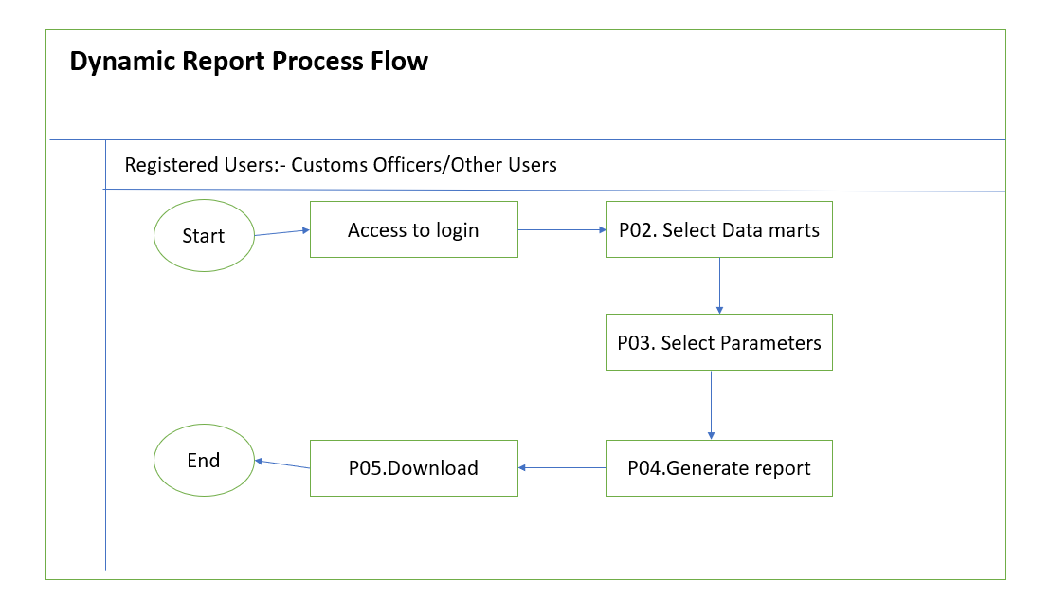

Process Steps
P01: Access to login
The registered user can access the report using valid credentials
P03: Select data marts
After accessing, user can select the data marts.
P03: Select the parameters
Register user can select the parameters to filter the data (Start date and End date)
P04: Generate Report
user can generate the Report
P05: Download the report
After selecting all field and parameters, registered user can export to PDF, Excel report.

Use case for Dynamic report
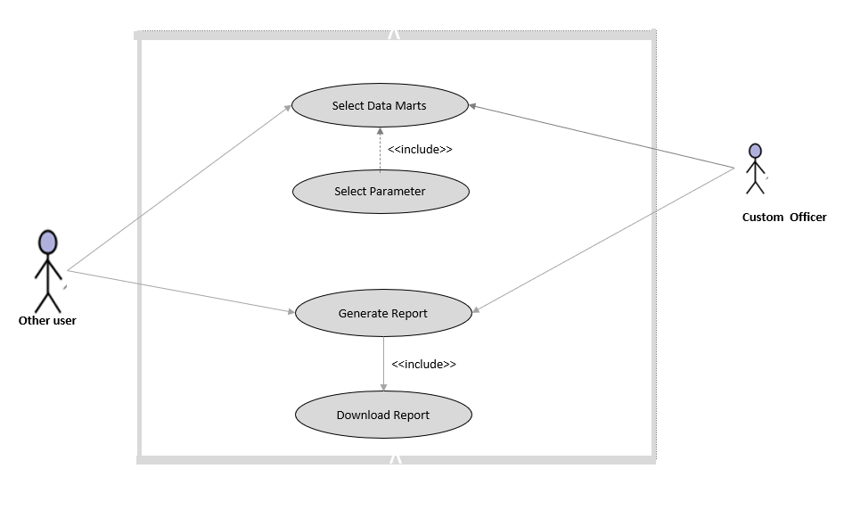

Dynamic Reports Fact transaction mapping table
Dynamic Report Fact Transaction Mapping Table contain main dynamic report data and this data comprises of the estimation measurement or actualities of the dynamic report mapping procedure and it can help to analysis the dynamic report and to get utilized in the live report.

Following are the list of FACT table for the dynamic report
Sl.no | List of Fact table | Types | Users
 | eCMS_FACT_DECLARATION_LINE_ITEMS | Dynamic | Customs
 | eCMS_FACT_REVENUE | Dynamic | Customs/Revenue
 | eCMS_FACT_EXEMPTION | Dynamic | Customs
 | eCMS_FACT_CLEARANCE | Dynamic | Customs
 | eCMS_FACT_OFFENCE | Dynamic | Customs
 | ECMS_FACT_REFUND | Dynamic | Customs/Revenue
 | eCMS_FACT_MANIFEST | Dynamic | Customs
 | eCMS_FACT_PASSENGER_MANIFEST | Dynamic | Customs

Following are the list of Pre-defined reports
Sl.no | List of Data Marts |  | Types
 | BTC & TARIFF SCHEDULE |  | Pre-define Format | Customs
 | BHUTAN TRADE STATISTIC | Pre-define Format |  |  | Customs/Other Users

ECMS_ Fact_Declaration_Line__item
FIELDS | FORMAT | Description | Transaction mapping Fact table for Declaration
DECLARATION ID | N..30 | PK | Auto Increment Number for Fact TABLE
REGIME_REFERENCE_NO | AN..1 | FK to Regime Dimension | eCMS_Decleration.header.Regime reference no
DECLARATION TYPE | AN..6
DECLARATION NUMBER | AN..35 |  | eCMS_Declaration. Header. Declaration Number
DECLARATION DATE | Datetime |  | eCMS_Decleration. Header.Decleration_Date
CLEARING AGENT CODE | AN..10 | FK to Clearing Agent Dimension | eCMS_Declaration. Header.Clearing Agent Code
CLEARING AGENT_NAME | AN..100 |  | eCMS_Declaration. Header. Clearing agent Name
IMPORTER TPN | AN..35 | FK to HS Code dimension | eCMS_Declaration.Header.Importer TPN
NAME OF IMPORTER | AN..100 | FK to Time Dimension | eCMS_Declaration. Header.Name of Exporter
EXPORTER TPN | AN..35 |  | eCMS_Declaration.Header.Exporter TPN
NAME OF EXPORTER | AN..100 |  | eCMS_Decleration.Header.Name of Exporter
MANIFEST Number | AN..35 |  | eCMS_decleration.header.manifest reference number
COSIGNMENT COUNTRY | A..2 | FK to Country code Dimension | eCMS_Declaration.header.consignment country key
MODE OF TRANSPORT | AN..1 |  | eCMS_Decleration.header.mode of transport
CONSIGNEE ID | AN..35 |  | eCMS_Decleration.header.consigned id
NAME OF CONSIGNEE | AN..100 |  | eCMS_Declaration.header.name of Consignee
CONSIGNOR ID | AN..35 |  | eCMS_Decleration.Header.Consignee id
NAME OF CONSIGNOR | AN..100 |  | eCMS_Declaration.header.Name of consignor
CUSTOMS OFFICE | AN..35 | FK to Cutsoms Office Dimension | eCMS_Decleration.header.custom office
TYPE OF CURRENCY | AN..3 | FK to Currency code Dimension | eCMS_Declaration.header.exchange currency
INVOICE NUMBER | AN..35 |  | eCMS_Declaration.header.innvoice number
INVOICE DATE | DATETIME |  | eCMS_Declaration.header.invoice date
INVOICE VALUE | N..18.2 |  | eCMS_Declaration.Header. invoice value
EXCHANGE RATE | N..12.5 | FK to Currency Code dimension | eCMS_Decleration.header.Exchange Rate
CUSTOMS PROCEDURE CODE | AN..6 | FK to CPC Dimension | eCMS_Decleration.header.CPC.Custom procedure code
BTCCODE | AN..18 | FK to HS Code dimension | eCMS_Declaration. Header.BTCCode
DESCRIPTION OF BTCCODE | AN..512 |  | eCMS_Declaration. Header. Description of BTCCODE
STANDARD UNIT | AN..3 | FK to UOM Code dimension | eCMS_Declaration. Header.Standard Unit
ITEM COUNTRY OF ORIGIN CODE | AN..2 | FK to Country Code dimension | eCMS_Declaration. Items invoice.items country of origin code
ITEMS_QUANTITY | N..18.2 |  | eCMS_Declaration. Invoice items.quantity of items
ITEMS_FREIGHT | N..18.2 |  | Ecms_decleration.invoice items.Freight of items
ITEMS_ INSURANCE | N..18.2 |  | eCMS_Declaration.invoice items.insurance of items
ITEMS_ TRANSACTION VALUE | N..18.2 |  | eCMS_Declaration.invoice items.Transaction value of items
ITEMS_CDAMOUNT | N..18.2 |  | eCMS_Declaration. Invoice items.customs duty amount of items
ITEMS_GTAMOUNT | N..18.2 |  | eCMS_Declaration. Invoice Items.Green tax amount of items
ITEMS_EETAMOUNT | N..18.2 |  | eCMS_Declaration invoice item vechile. EET Amount of items
ITEMS_GSTAMOUNT | N..18.2 |  | eCMS_Declaration.Invoice items vechile.GST amount of items
ITEMS_DEPO SURCHARGEAMOUNT | N..18.2 |  | eCMS_Declaration.Invoice items. Depo surcharge amount of items
ITEMS_FINE&PENALTIESAMOUNT | N..18.2 |  | eCMS_Declaration. Invoice of items.Fines and Penalties of items
ITEMS_ GROSS WEIGHT | N..18.2 |  | eCMS_Declaration. Invoice.items Gross weight
ITEMS_NO_OF_PACKAGES | N..12.2 |  | eCMS_Declaration. Invoice. Items No of packages
ITEMS_PACKAGES_TYPE | AN..35 |  | eCMS_Declaration. Invoice.items packages Type
PREFERENTIAL TARIFF | N..12.6 |  | eCMS_Declaration. Invoice items.prefferential tariff
CREATED BY | AN..35 |  | eCMS_Declaration.CreatedBy
CREATED ON | datetime |  | eCMS_Declaration.Createdon
LAST UPDATED BY | AN..35 |  | eCMS_Declaration.
LAST UPDATED ON | datetime |  | eCMS_Declaration.

ecms_Fact_Revenue
FIELDS | FORMAT | Description | Transaction Table mapping for Revenue
REVENUE ID | AN..20 | Fact Table Surrogate Key (Primary Key) | _Revenue.revenue id
CUSTOMS OFFICE | AN..35 |  | ECMS_Fact_Revenue.customs office code
DEMAND NOTICE NUMBER | AN..20 |  | ecms_Fact_Revenue. Revenue key
DEMAND NOTICE DATE | SMALLDATE |  | ECMS_Fact_Revenue.Transaction date key
REGIME | AN..1 | FK REGIME CODE dimension | ECMS_Fact_Revenue.regime code
REGIME NAME | AN..70 |  | ECMS_Fact_Revenue.regime name
DECLARATION NUMBER | AN..35
DECLARATION DATE | SMALLDATE
IMPORTER_TPN | AN..35 |  | ECMS_Fact_Revenue.importer_code
IMPORTER_NAME | AN..100 |  | ECMS_Fact_Revenue.importer_name
MODE OF PAYMENT | AN..35 |  | ECMS_Fact_Revenue.mode of payment
RECEIPT NUMBER | AN..35 |  | ECMS_Fact_Revenue.Revenue key type
RECEIPT DATE | SMALLDATE |  | ECMS_Fact_Revenue.Revenue_code
TYPE OF TAXES | AN..35 | FK TAXTYPE DIMENSION
TAX AMOUNT | N..18.2 |  | ECMS_Fact_Revenue.amount
TRANSACTION WAIVED | N.18.2 |  | ECMS_Fact_Revenue.transaction waived
PAYMENT STATUS | AN..50
CREATED BY | AN..35 |  | eCMS_Declaration.CreatedBy
CREATED ON | datetime |  | eCMS_Declaration.Createdon
LAST UPDATED BY | AN..35 |  | eCMS_Declaration.
LAST UPDATED ON | datetime |  | eCMS_Declaration.

ECMS Fact Exemption
FIELDS | FORMAT | DESCRIPTION | TRANSACTION FACT MAPPING TABLE FOR EXEMPTION
EXEMPTION ID | AN..20 | pk | Exemption.Exemptionid
EXEMPTION ISSUED FOR | AN..35 |  | Exemption _header_exemption details.type
EXEMPTION NUMBER | AN..35 |  | Exemption_header_act details.liscense number
EXEMPTION DATE | DATETIME |  | Exemption_header_application details.date of application
IMPORTER TPN | AN..35 |  | Exemption _header_act details.tpn number
NAME OF IMPORTER | AN..100 |  | Exemption _act_header_act details.party name
CUSTOMS OFFICE | AN..35 | fk customs office code dimension | Exemption _header.office of exemption
TYPE OF EXEMPTION | AN..50 |  | Exemption_Header_Exemption details.Type
ISSUED FOR | AN..100 |  | Exemption_header_exemption details.issued for
CATEGORY | AN..100 |  | Exemption_header_exemption details.category
INVOICE NUMBER | AN..40 |  | Exemption_invoice and supplier_invoice details.invoice number
INVOICE DATE | DATETIME |  | Exemption_invoice and supplier_invoice details.invoice date
INVOICE AMOUNT | N..18.2 |  | Exemption_invoice and supplier_invoice details.invoice amount
TYPE OF CURRENCY | AN..3 | fk currecy code dimension | Exemption_invoice and supplier_invoice details.invoice currency
BTCCODE | AN..10 | FK HS CODE DIMENSION | ACT_Items Details. HS Code
COMMODITY DESCRIPTION | AN..500 |  | _ACT_Items Details.Commodity description
COUNTRY OF ORIGIN OF GOODS | AN..2 | FK COUNTRY CODE DIMENSION | ACT_Items Details.Country of Origin of Goods
EXEMPTED QUANTITY | N..18.2 |  | Details_Items Details.Quantity
EXEMPTED VALUE | N.18.2 |  | Details_Items Details.Amount
UOM | AN..3 | FK OUM CODE DIMENSION | Details_Items Details.UOM
DUTY FREE PRIVILEGE TYPE KEY | AN..50 | FK PRIVILEGE TYPE CODE DIMENSION | Duty free Quota_Header_Party Details.privilege Type
CREATED BY | AN..35 |  | Exemption Created By
CREATED ON | DATETIME |  | Exemption Created On
LAST UPDATED BY | AN..35 |  | Exemption LastUpdated By
LAST UPDATED ON | DATETIME |  | Exemption LastUpdated On

ECMS_Fact_Clearances
FIELDS | FORMAT | Description | TRANSACTION FACT MAPPING TABLE FOR CLEARANCE
CLEARANCE ID | AN..20 | primary key | Auto increment number primary key for clearance
DECLARATION REFERENCES NUMBER | AN..35 | declaration references number | Ecms_clearance_document details. Declaration number
CLEARING AND FORWARDING AGENT | AN..50 | fk_diminision to cfa | Eems_clearing and forwarding agent.name of cfa
SUBMITTED DATE | DATETIME | declaration documentary submitted date | Ecms_clearance document checks completion. Submitted date
NAME OF VERIFIER | AN..100 | name of the verifier | Ecms_clearance document verification check. Verifier name
START DATE | DATETIME | documentary checks start date | Ecms_clearance document verification check completeion.start date
END DATE | DATETIME | documentary check end date | Ecms_clearance document verification check completeion.end date
DEMAND NOTICE NUMBER | AN..35 | payment demand references number | Ecms_clearance document verification check completeion.pyaments number
START DATE | DATETIME | payment start date | Ecms_clearance payments. Start date
END DATE | DATETIME | payments end date | Ecms_clearance payments. End date
NAME OF VALUATOR | AN..100 | name of valuator officer | Ecms_clearing.valution.name of valuator
START DATE | DATETIME | valuation starts date | Ecms_clearing.valution.start date
END DATE | DATETIME | valuation end date | Ecms_clearing.valuation.end date
NAME OF RISK OFFICER | AN..100 | name of risk officer | Ecms_clearing.risk valuation.name of risk officer
START DATE | DATETIME | risk valuation start date | Ecms_clearing.risk valuation. Start date
END DATE | DATETIME | risk valuation end date | Ecms_clearing.risk valuation.end date
NAME OF PHYSICAL INSPECTION | AN..100 | name of fiscal inspection officer | Ecms_clearing.fiscal inspection.name of inspection name
START DATE | DATETIME | fiscal inspection start date | Ecms_clearing.fiscal inspection.start date
END DATE | DATETIME | fiscal inspection end date | Ecms_clearing.fiscal inspection.end date
ADDITIONAL DEMAND NOTICE NUMBER | AN..35 | payment demand references number | Ecms_clearance document verification check completeion.pyaments number
ADDITIONAL PAYMENT START DATE | DATETIME | NAME OF RISK OFFICER | Name of risk officer
ADDITIONAL PAYMENT END DATE | DATETIME | NAME OF RISK OFFICER | Name of risk officer
NAME OF RELEASE OFFICER | AN..100 | name of release officer | Ecms_clearing.realese order.name of officer
START DATE | DATETIME | release start date | Ecms_clearing.realese order.start date
END DATE | DATETIME | release end date | Ecms_clearing.realese order.end date
CREATE BY | AN..100 |  | Ecms_clearing.created by system user
CREATE ON | DATETIME |  | Ecms_clearing.creadet on .system date
UPDATED BY | AN..100 |  | Ecms_clearing.updated by.system user amendments
LAST UPDATED ON | DATETIME |  | Ecms_clearing.last updation on.date of last amendments

ECMS_Fact_Offence
FIELDS | FORMAT | Description | Transaction Mapping table for Offences
OFFENCE ID |  | Auto number(primary key) | eCMS_Fact_Primary key. Offences id
OFFENCE NUMBER | AN..35 |  | eCMS_Fact_Header.Offences Number
OFFENCE DATE | DATETIME |  | eCMS_Fact_Header.Offences Date
OFFENCE CATEGORY | AN..35 |  | eCMS_Fact_Header.Offences Category
OFFENCE TYPE | AN..35 | FK offence type code dimension | eCMS_Fact_Header.Offences Type
OFFENCE SOURCE | AN..35 |  | eCMS_Fact_Header.Offences Source
DECLARATION NUMBER | AN..35 |  | eCMS_Fact_Header.decleration number
REGIME | AN..20 | FK regime code dimension | eCMS_Fact_Header.Regime
IMPORTER TPN | AN..20 |  | eCMS_Fact_Header.Importers Exporter
NAME OF IMPORTER | AN..50
OFFENCE DESCRIPTION | AN..1000 |  | eCMS_Fact_Header.Offence description+
HS CODE | AN..10 | FK hs code dimension | eCMS_Fact_Items details. HS Code
UOM | AN..5 | FK UOM code dimension | eCMS_Fact_items details.UOM
QUANTITY IN OFFENCE | N..18.2 |  | eCMS_Fact_items details. Quantity in Offence
OFFENCE OUTCOME | AN..35 |  | eCMS_Fact_items details. Offences Outcome
COUNTRY OF ORIGIN OF GOODS | AN..3 | FK country code dimension | eCMS_Fact_items details. Country Origin
CUSTOMS VALUE | N..18.2 |  | eCMS_Fact_items details. Customs Value
TYPE OF CURRENCY | AN..3 | FK currency code dimension | eCMS_Fact_items details. Local currency
CUSTOMS OFFICE | AN..35 | FK customs office code dimension | eCMS_Fact_Approval.Customss Office
TAX TYPE | AN..5 | FK tax type code dimension | eCMS_Fact_Demand note. Taxes Type
TAX DESCRIPTION | AN..45 |  | eCMS_Fact_Demand note. Taxes Description
TAX AMOUNT | N..18.2 |  | eCMS_Fact_Demand note. Taxes Amount
AMOUNT TO BE PAYABLE | N..18.2 |  | eCMS_Fact_Demand note. Totals Payable
CREATED BY | AN..35 |  | eCMS_Declaration.CreatedBy
CREATED ON | datetime |  | eCMS_Declaration.Createdon
LAST UPDATED BY | AN..35 |  | eCMS_Declaration.
LAST UPDATED ON | datetime |  | eCMS_Declaration.

ECMS_Fact_Refund
FIELDS | FORMAT | Description | Transaction Mapping table for Refund
REFUND ID | AN..10 | PK | eCMS_Fact_Primary key. Refund id
REFUND REFERENCES NO | AN..20 |  | eCMS_Fact_Refund Details. Refund References No
TAXPAYER NO (TPN) | AN..35 |  | eCMS_Fact_Refund Details. Taxpayer No (TPN)
TAXPAYER NAME | AN..100 |  | eCMS_Fact_Payee Details. Taxpayer Name
REFUND MODE | AN..20 |  | eCMS_Fact_Refund Details. Refund Mode
REFUND APPLICATION NO | AN..30 |  | eCMS_Fact_Refund details. Refund Application No
BUSINESS TRANSACTION NUMBER | AN..20 |  | eCMS_Fact_Refund details. Business Transaction Number
PAYMENT RECEIPT NUMBER | AN..30 |  | eCMS_Fact_Refund details. Payment Receipt Number
REFUND TYPE | AN..20 |  | eCMS_Fact_Refund details. Refund Type
REFUND AMOUNT | N..18.2 |  | eCMS_Fact_Refund details. Refund Amount
REFUND TAX TYPE | AN..20 | FK Tax type code dimension | eCMS_Fact_Refund Details. Refund Tax Type
SUBMITTED DATE | DATETIME |  | eCMS_Fact_Refund details. Submitted date
BANKS | AN..5 | FK Bank code dimension | eCMS_Fact_Refund details. Banks
ACCOUNT NO | AN..10 |  | eCMS_Fact_Refund details
REASON FOR REFUND | AN.500 |  | eCMS_Fact_Refund details. Reason for refund
CREATED BY | AN..35 |  | eCMS_Declaration.CreatedBy
CREATED ON | DATETIME |  | eCMS_Declaration.Createdon
LAST UPDATED BY | AN..35 |  | eCMS_Declaration.
LAST UPDATED ON | DATETIME |  | eCMS_Declaration.

ECMS_Fact_Manifest
FIELDS | FORMAT | Description | Transactional Mapping Table for Manifest
MANIFEST ID | AN..35 | PK | eCMS_Fact_Manifest Primary Key.Manifest id
AIRCRAFT CODE | AN..35 |  | Master manifest Header.Aircraft Code
AIRLINE NAME | AN..35 |  | Master manifest Header.Airline Name
FLIGHT NO | AN..35 |  | Master manifest Header.Flight No
MANIFEST NUMBER | AN..35 |  | Master manifest Header.Manifest Number
MODE OF TRANSPORT | AN..35 |  | Manifest.Truck.Means of Transport
INBOUND OUTBOUND | AN..6 |  | Master manifest Header.Inbound Outbound
PORT ARRIVAL | AN..35 |  | Master manifest Header.Port Arrival
PORT OF LOAD | AN..35 |  | Master manifest Header.Port of Load
CUSTOMS OFFICE | AN..35 |  | Master manifest Header.Customs Office
NO OF AWBS | N..15 |  | Master manifest Header.No of AWBs
AWB NUMBER | AN..35 |  | Air Waybill.AWB Number
BL TYPE | AN..5 |  | Air Waybill.Bl Type
CONSOLIDATOR PARTY CODE (TPN) | AN..50 |  | Air Waybill. Consolidator Party Code (TPN)
CONSIGNMENT NO | AN..25 |  | Air waybill. Consignment No
NO OF PKGS | N..8 |  | Invoice Details.Number of packages
GROSS WEIGHT | AN..35 |  | Invoice Details.Gross Weight
UOM | AN..3 |  | Air Waybill.Gross Weight UOM
VOLUME | N..14,3 |  | Invoice Details.Volume
VOLUME UOM | AN..4 |  | Air Waybill.Volumn UOM
PORT LOAD | AN..6 |  | Air Waybill.Port Load
PORT DISCHARGE | AN..6 |  | Air Waybill.Port Discharge
COUNTRY OF ORGIN | AN..2 |  | Air Waybill.Country of Orgin
COUNTRY OF DESTINATION | AN..2 |  | Air Waybill.Country of Destination
GOODS DESCRIPTION | AN..3500 |  | Invoice Details.Goods Description
CONSIGNEE NAME | AN..70 |  | Air Waybill.Consignee Name
CONSIGNEE COUTNRY | AN..2 |  | Air Waybill.Consignee Coutnry
CONSIGNOR NAME | AN..70 |  | Air Waybill.Consignor Name
CONSIGNOR COUNTRY | AN..2 |  | Air Waybill.Consignor Country
BOUND TYPE | N..15 |  | Road manifest Header.Bound type
ENTRY POINT | AN..5 |  | Road manifest Header.Entry Point
ARRIVAL POINT | AN..5 |  | Road manifest Header.Arrival Point
BORDER OFFICE | N..15 |  | Road manifest Header.Border Office
REGIME | N..15 |  | Road manifest Header.Regime
AGENT NAME | AN..200 |  | Road manifest Header.Agent Name
TOTAL INVOICE VALUE | N..15,2 |  | Road manifest Header.Total invoice Value
NO OF INVOICE | N..15 |  | Road manifest Header.No of invoice
GATE-IN DATE | DATETIME |  | Road manifest Header.Gate in Date
INVOICE NO. | AN..35 |  | Invoice Details. Invoice number
INVOICE DATE | DATETIME |  | Invoice Details.invoice date
INVOICE ITEM VALUE | N..15,2 |  | Invoice Details.invoice items Value
FREIGHT TYPE | N..15 |  | Invoice Details.Freight type
FREIGHT AMOUNT | N..15,2 |  | Invoice Details. Freight Amount
CURRENCY | N..15 |  | Invoice Details.Currency
INVOICE DATE | DATETIME |  | Truck.Invoice Date
CONTAINER NO | AN..17 |  | Continer.Container No
TARE WEIGHT | N..16,3 |  | Container.Tare Weight
NET WEIGHT | N..16,3 |  | Container.Net Weight
CREATED BY | AN..35 |  | eCMS_Declaration.CreatedBy
CREATED ON | DATETIME |  | eCMS_Declaration.Createdon
LAST UPDATED BY | AN..35 |  | eCMS_Declaration.
LAST UPDATED ON | DATETIME |  | eCMS_Declaration.

ECMS_Fact_Passenger_manifest
FIELDS | FORMAT | DESCRIPTION |  | TRANSACTIONS MAPPING TABLE OF PASSENGER MANIFEST
PASSENGER MANIFEST ID | AN..35 | PK | Primary key. Passenger manifest id
MANIFEST NUMBER | AN..35 | FK | Passenger manifest Header. Manifest Number
AIRCRAFT NO | AN..35 |  | Passenger manifest Header. Aircraft No
AIRLINE NAME | AN..35 |  | Passenger manifest Header. Aircraft Name
FLIGHT NO | AN..35 |  | Passenger Manifest Header. Flight No
LAST PORT OF CALL | AN..35 |  | Passenger manifest header. Last port of call
LAST PORT OF INITIAL ARRIVAL | AN..35 |  | Passenger Manifest Header. Last port of Initial arrival
SUBSEQUENT PORT OF CALL | AN..35 |  | Passenger Manifest Header.subsiquent port of call
CUSTOMS OFFICE | AN..35 |  | Passenger manifest Header. Customs Office
SCHEDULED ARRIVAL DATE | DATETIME |  | Passanger manifest Header. Scheduled Arrival Date
SCHEDULED DEPARTURE DATE | DATETIME |  | Passenger Manifest Header. Scheduled Departure Date
NUMBER OF PASSENGERS | N..15 |  | Passenger manifest Header. Number of Passengers
PASSPORT NUMBER | AN..70 |  | Passenger.Passport number
DATE OF BIRTH | DATETIME |  | Passenger. Date of Birth
FIRST NAME | AN..70 |  | Passenger.First Name
MIDDLE NAME | AN..70 |  | Passenger.Middle Name
GENDER | AN..10 |  | Passenger.Gender
CITIZENSHIP | AN..35 |  | Passenger.Citizenship
BAGGAGE INFORMATION | AN..70 |  | Passenger. Baggage Information
SEAT NO | AN..35 |  | Passenger. Seat No
PASSENGER NAME RECORD LOCATOR NUMBER | AN..70 |  | Passenger. Passenger Name record locator number
CREATED BY | AN..35 |  | eCMS_Declaration.CreatedBy
CREATED ON | DATETIME |  | eCMS_Declaration.Createdon
LAST UPDATED BY | AN..35 |  | eCMS_Declaration.
LAST UPDATED ON | DATETIME |  | eCMS_Declaration.

ECMS_FACT_BHUTAN TRADE STATISTIC

FIELDS | FORMAT | DESCRIPTION | TRANSACTIONS MAPPING TABLE OF BHUTAN TRADES STAISTIC
BST_ID | AN..10
SECTION ID | AN..5 | FK SECTION CODE DIMENSION | eCMS.Section.Section code
SECTION DESCRIPTION | AN..100 |  | eCMS.Section.Section description
CHAPTER ID | AN..5 | FK CHAPTER CODE DIMENSION | eCMS.Chapter. Chapter code
CHAPTER DESCRIPTION | AN..500 |  | eCMS. Chapter. Chapter description
HEAD ID | AN..5 | FK HEAD CODE DIMENSION | eCMS.Head.Head code
HEAD DESCRIPTION | AN..500 |  | eCMS. Head. Head description
SUB HEAD ID | AN..5 | FK HEAD CODE DIMENSION | eCMS.Head.SUBHead code
SUB HEAD DESCRIPTION | AN..500 |  | eCMS. Head. SUBHead description
BTC CODE | AN..10 | FK HS CODE DIMENSION | eCMS_Declaration. Header.BTCCode
BTC CODE DESCRIPRION | AN..500 |  | eCMS_Declaration. Header. Description of BTCCODE
QUANTITY | N..18.2 |  | eCMS_Declaration. Items. Quantity
VALUE | N..18.2 |  | eCMS_Declaration. Items. Value
UOM | AN..3 | FK UOM CODE DIMENSION | eCMS_Declaration. Items. UOM
COUNTRY OF ORIGIN | AN..2 | FK COUNTRY CODE DIMENSION | eCMS_Declaration. Items. Country of Orign_ID
CUSTOMS OFFICE | AN..35 | FK CUSTOMS OFFICE CODE DIMENSION | eCMS_Declaration.Header. Customs office
CREATED BY | AN..35 |  | eCMS_Declaration.CreatedBy
CREATED ON | DATETIME |  | eCMS_Declaration.Createdon
LAST UPDATED BY | AN..35 |  | eCMS_Declaration.
LAST UPDATED ON | DATETIME |  | eCMS_Declaration.

BTC & TARIFF SCHEDULE
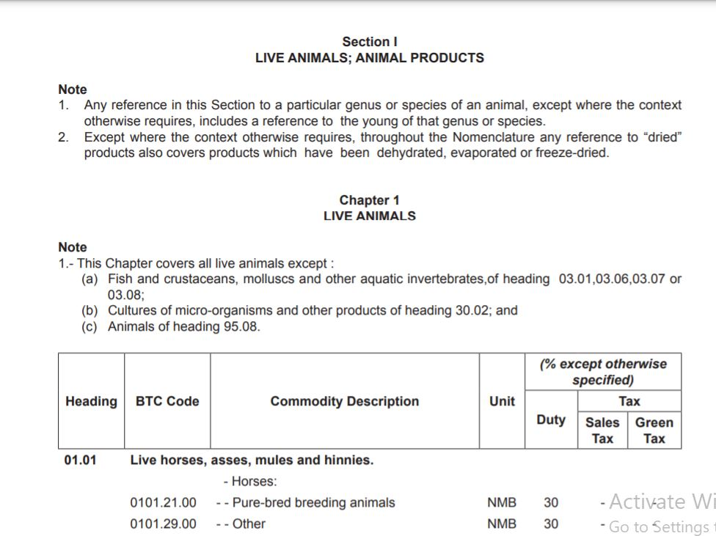

Dash board

